July 2, 2022
Bromma, Sweden

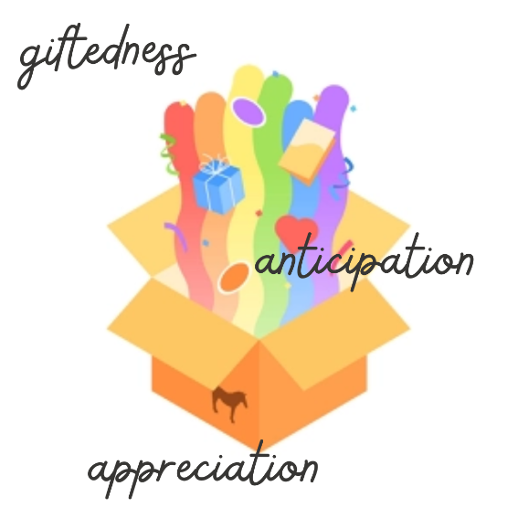
Unboxing Bibliodrama
Yesterday, we ended the first phase of the Bibliodrama training course. For the first five days since we started, we spent our mornings and afternoons participating in Bibliodrama workshops. Days began with rounds of sharing dreams and leftovers from the previous day’s activities. This we did around Yesterday, we ended the first phase of the Bibliodrama training course.
For the first five days since we started, we spent our mornings and afternoons participating in Bibliodrama workshops. Days began with rounds of sharing dreams and leftovers from the previous day’s activities. This we did around a centerpiece that beautifully tied the space together while tickling our minds to imagine what was in store for us that day. We warmed up by dancing to the beat of wonderful music—pieces that moved me to let go of my inhibitions and allowed me to heed the desire of my body to move and be moved. We read and reread biblical texts; chopped them up into smaller chunks; played with the words (for example, chanting our chosen words all at the same time, creating a cacophony that was ironically harmonious); zoomed in on what we deemed to be most significant to us; and turned them to life through role-plays, tableaus, and artwork, to name but a few. For almost every activity, we had the chance to share in small and large groups our thoughts and feelings about what had just transpired.
In the evenings, we reviewed the day. We talked about some of the elements that were interesting or unclear and discussed questions we had both as participants and facilitators.
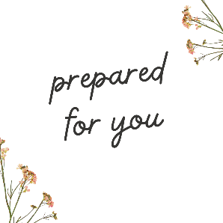
I'm quite full and satisfied after all that receiving.
Today, we will be given instructions that shall guide us as we shift to the role of facilitators next week. I feel greatly enriched by my experience as a participant, but I feel insecure about my capacity to deliver a workshop well enough to enrich my participants. What a daunting task it is!
But, I find consolation in a phrase that stuck with me from our workshop yesterday: “prepared for you”.
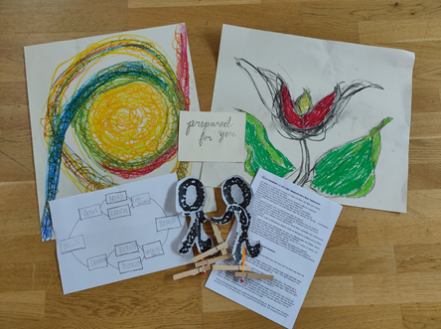
And so, I look forward to being assured that the way has been prepared. This also means that what is needed has been provided. All I need to do is to keenly recognize what has already been given and prepared. And in so doing, may I facilitate my participants’ encounter with the text.
There are three themes that can describe my takeaways from the first part of the course:
First is giftedness. We have received so much presence and presents, such as: the opportunity to partake in the course through the support of Het Leerke, EBN, and Erasmus; the wealth of experiences, methods, materials, and insights that Lotta, LG, Andrea, and Anna have shared with us; the venue blessing us to be in close proximity to nature; and the generosity of the participants to open themselves to the group, bringing in their respective backgrounds that add flavor and texture to the overall experience. We have all that we need. We have been gifted.
The second is appreciation. Recognizing what we have received, all of us have expressed how grateful we are to our facilitators and co-participants. The invitation is to translate gratitude to a motivation to use our gifts to gift others through facilitating Bibliodrama. We can express our appreciation through the careful planning and crafting of our respective workshops.
Third is anticipation, which for me is about patient waiting for the good that can come out despite feelings of anxiety. Most of the gifts we receive come wrapped. On the one hand, there is a sense of eagerness to discover what is in store for us. On the other hand, not knowing what to expect can also make one worry. With God’s grace, we trust that Bibliodrama can bless us. Every workshop brings something new to the participants and the facilitators. But new things are not always pleasant or meaningful, at least in the beginning or on the surface. I hope we choose to anticipate. This can involve grappling with the text. We have to be kind to ourselves, despite our lack of understanding at the moment.
Nev

